**FINAL REPORT**

* **Executive Summary:**

**Summary of the project**

This customer segmentation project aimed to enhance marketing strategies by analyzing customer data from various sources. Using Python and tools like vs code Jupyter Notebook, Matplotlib, and Scikit-learn, we cleaned and analyzed the data, identified distinct customer segments through clustering techniques, and visualized the results using insightful graphs and charts. Key findings revealed clear customer groups based on Annual_income distributuions,Spending Score Distributions and demographics etc.. These insights will guide targeted marketing efforts, improve customer engagement, and optimize business operations. The project underscores the importance of data-driven decision-making in fostering personalized customer experiences and driving strategic growth in the retail sector.

**OBJECTIVES**

The primary objective of this project is to analyze customer data from a retail store and segment customers into distinct groups based on their purchasing behavior. By identifying these segments, the retail store can tailor its marketing strategies to better meet the needs of each customer group, ultimately enhancing customer satisfaction and boosting sales.

* Improving marketing effectiveness
* Enhancing customer experience
* Optimizing product recommendations
* Extracting Meaningful Insights
* Optimize business operations

**OUTCOMES**

Highlight the main outcomes and insights gained from the customer segmentation analysis, focusing on the identified customer segments and their characteristics.

**Introduction:** Project background and objectives

Customer segmentation is a crucial aspect of customer relationship management (CRM) and marketing strategies. In the context of a retail store, understanding different customer segments allows the store to:

* **Develop Targeted Marketing Campaigns:** Tailor promotions and advertisements to specific customer groups based on their purchasing habits and preferences.
* **Personalize Customer Experiences:** Offer personalized recommendations and services to improve customer satisfaction and loyalty.
* **Optimize Product Offerings:** Adjust inventory and product offerings to align with the preferences of different customer segments.
* **Increase Customer Retention:** Implement strategies to retain high-value customers and reduce churn rates.
* **Enhance Sales and Revenue:** Identify opportunities for cross-selling and up-selling to maximize sales and revenue.
* **Methodology:** Steps taken to achieve the objectives

**Data Collection:** Detail the sources from which customer data was gathered, such as records, customer details, stores.(e.g the dataset was taken,it is present in Kaggle)

**Data Cleaning**: Outline the process used to clean and preprocess the data, including handling missing values, removing duplicates, and standardizing formats.(e.g.,libraries-pandas)

**Exploratory Data Analysis (EDA):** Summarize the techniques employed to explore the dataset, such as descriptive statistics, distribution plots, and correlation analysis.(e.g.,libraries-Matplotlib,seaborn)

**Clustering Techniques:** Explain the clustering algorithms chosen and their rationale (e.g., K-means for its simplicity).

**Visualization:** Describe how the results of customer segmentation were visualized (e.g., using Matplotlib and Seaborn for creating charts and graphs, or interactive dashboards in tools like Power BI).

**Results:** Findings from Data Analysis and Segmentation

**Data Analysis Insights:**

Utilized Python and vs code for data cleaning and exploratory data analysis (EDA).

Identified key metrics such as age distributions, gender distributions, and and Annual_income distributions.

Identified the relationship between Income and SpendingScore

**Segmentation Findings:**

* + Applied clustering algorithms (e.g., K-means) to categorize customers into distinct segments.
  + Discovered clusters based on spending patterns, AnnualIncome, and customer Age and Gender.

**Conclusion:** Key Insights and Recommendations

**Key Insights:**

**Customer Segmentation:** Identified distinct customer segments based on age, SpendingScore, and AnnualIncome.

* **Marketing Effectiveness:** Highlighted opportunities for targeted marketing strategies tailored to different customer segments.

**Recommendations:**

* **Personalized Marketing:** Implement personalized marketing campaigns to cater to specific customer segments' preferences and behaviors.
* **Customer Experience Enhancement:** Enhance customer experience by tailoring product offerings and promotions based on segment insights.
* **Appendices:** Additional charts(e.g Age Distribution by gender and gender distribution)

Code Snippets-(Examples)

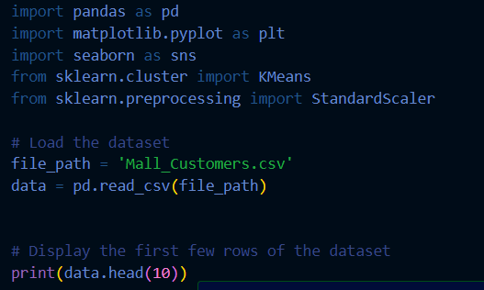

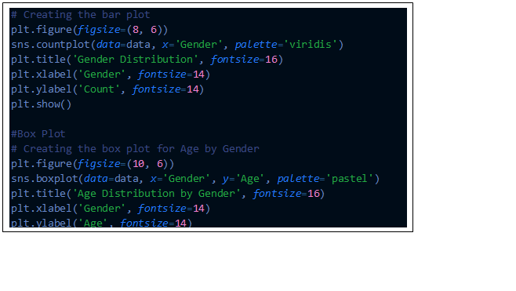

References:

<https://www.cipherschools.com/>

<https://matplotlib.org/>

https://scikit-learn.org/stable/